**RF STUDY Iridium**

Just a draft sheet to take track of the results

26/11 : Look into the link budget

We’ll refer to the document Iridium antenna ird-swg03-wp05-draft iridium ams(r)s tech manual - 021506 (Documents folder on the Drive) as the “Iridium antenna specs”[1] and to Antenna_mpa-d254-1621_datasheet.pdf (Datasheets folder on the Drive) as the “Antenna data sheet”[2],, Iridium9603n-satellite-module.pdf (Datasheets folder on the Drive) as the “Modem data sheet”[2]

Found a complete link budget here <https://licensing.fcc.gov/cgi-bin/ws.exe/prod/ib/forms/attachment_menu.hts?id_app_num=102703&acct=265137&id_form_num=15&filing_key=-260629> [6]

For the downlink: attachment schedule S DOC 32

For the uplink: attachment schedule S DOC 19

Pages used for theory

<https://en.wikipedia.org/wiki/Link_budget#:~:text=A%20simple%20link%20budget%20equation,multiplying%20the%20actual%20numeric%20ratios>. [3]

<http://www.sss-mag.com/pdf/an9804.pdf> [4]

We are in the “verification” side. We don’t need to design a new component but only to make sure that chosen components work together.

Link budget

First, we consider the uplink, namely payload → satellite

So we may write the link budget in the following form: [3]

$P_{rec }= {P_{in }G}_{e }(θ, ϕ) G_{r} (θ, ϕ){/ (L}_{FS }L_{ATM}L_{P,R}L_{P,T}L_{POL}L_{TX }L_{RX}L_{M})$

Now we characterize each term

$P_{rec}$ is the power received by the Iridium constellation from our device.

What we need to find out is whether it’s[4] bigger than the sensitivity $P_{rx}$ of the Iridium receiver

$P_{rec }> P_{rx }= SNR + Receiver Noise Floor$

I couldn’t find the Receiver Noise floor in the Iridium Antenna specs but there we can find enough information to compute SNR- However, Receiver Noise Floor might be negligible wrt to SNR value [4]

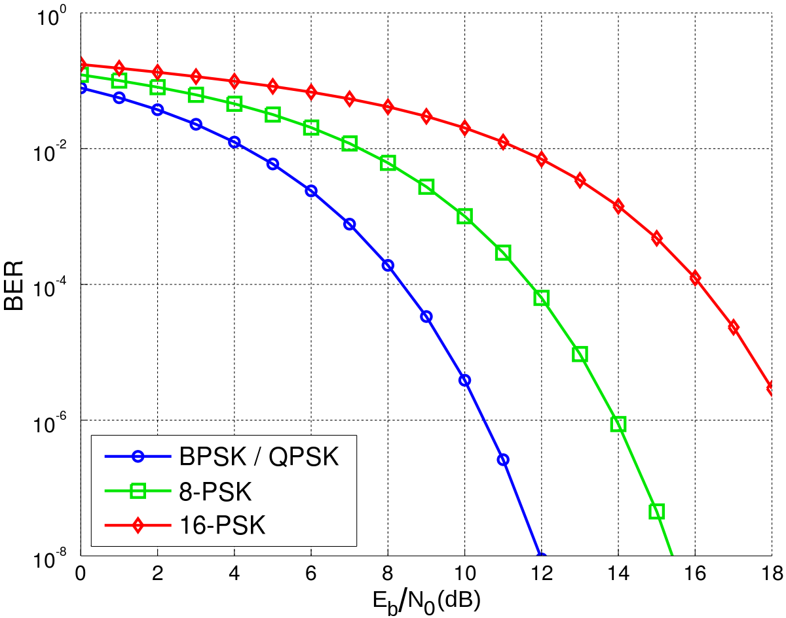

$SNR = E_{b }/ N_{0 }* R/B_{T}$ = 0.9768=

In [4], one may find the explanation of this equation.

Surprisingly, we know all these terms! I mean, actually in [1] the mention a $E_{b }/(N_{0 }+ I_{0 })$ of 6.1 dB=4.07 whose difference is not clear to me right now, maybe is linked to the difference btw SNR and CNR. Otherwise it is possible to recover $E_{b }/ N_{0 }$ from the BER = 0.02 (Bit Error Rate)[1] and the QPSK modulation [2] to one of these plots. The data rate R should be 19200 bps by default [5] but it’s a parameter we can set. In [1] they say there are different channels for different services. It’s not super clear which channel we’re going to use (maybe traffic channel?). I guess we can just assume R as in the modem configuration i.e. 19.2 kbps. The Bandwidth $B_{T}$ is 10MHz

$C/N_{0}$ found through formula on Matlab, taking into account G/T on Iridium budget sheet, k_B Boltzmann

If *N* bits are conveyed per symbol, and the gross bit rate is *R*, inclusive of channel coding overhead, the symbol rate can be calculated as:

$f_{s }= R/N$

In that case *M* = 2*N* different symbols. In a qpsk modulation we have N=2 because two bits are conveyed for each symbol (Hence 4 symbols in total can be written)

Then you convert it into $E_{b}/N_{0}$ with bit rate (3.5 kbps) or into $E_{s}/N_{0}$ with symbol rate (25 ksps). On the Iridium budget sheet there’s the requirement on the $E_{s}/N_{0}$ and the one you get should be higher than that. If it’s higher it means you have a lower BER so it’s ok. BER threshold is on the classic plot

**Downlink**

The link is established under the following two conditions

1 - Signal strength @receiver $P_{rec }$ > Receiver sensitivity = -116dBm = -146 dB (Modem data sheet)

2 - $E_{s}/N_{0}$ > required $E_{s}/N_{0}$ = 9.2 [6]

1 - We use the link budget equation in the following form: [3]

$P_{rec }= {P_{in }G}_{e }(θ, ϕ) G_{r} (θ, ϕ){/ (L}_{FS }L_{ATM}L_{P,R}L_{P,T}L_{POL}L_{TX }L_{RX}L_{M})$ S(Eq.1)

It’s mathematically a very simple equation. In this form it is linear, but it’s common to use it in decibels. In decibels we have the same terms but the multiplications are replaced by “+” and the divisions by “-”. The difficult part is to characterise every term.

$P_{in}$ is the power given to the signal from the Iridium satellite

$G_{e }(θ, ϕ)$ is the gain of the Iridium satellite antenna

Often, these two parameters are unified into the parameter $EIRP = P_{in}G_{e,max}$ and indeed in [6] we’ve got an EIRP of 20.9 dB which we’ll pick up.

$G_{r }(θ, ϕ)$ is the gain of the payload antenna which is available in [2] ,

Iridium communicates through a phased antenna array that we could try to characterise. I found some papers...

$L_{FS}= (λ/(4 π{R))}^{-2}$ is the free space loss

$λ= c/ f =$ 0.185 m

R depends if we consider the payload on Earth or on orbit, and some trigonometric calculations need to be done to estimate it accordingly to $θ,ϕ$.

For a simple 2D case and an elevation of E=45°, the resulting distance is approximately 1100 Km. In the best case R=H=780 Km. We may assume R = 1500 Km in a “standard”?

1.Assume E

$2. (R_{E}+H)sin θ= R_{E }cos E$ → $θ$

3. $R =\sqrt{(R_{E}+H)^{2}+{R_{E}}^{2}-2({R_{}}_{E}+H)R_{E}cos(π- θ- E)}$

$L_{FS}$ =160.1 dB

More study should be performed to estimate E. In [1] they say $Θ_{MIN }(=E)=8.2°$ and the antenna has a large beamwidth (100° both axes). Hence maybe we can take like E = 50° for the worst case scenario, but for now we’re not interested in it. Indeed, E might be one parameter we want to define from our link budget

$L_{Tx}$ are transmitter losses and might be modeled as the maximum cable losses indicated in [5] of 2 dB

$L_{Rx}$ are receiver losses and are to be searched in [1]

Couldn’t find any value in [1]

$L_{M}$ are diverse losses. They can be composed by many countable losses as the atmospheric loss $L_{atm}$ which can be estimated with the help of some weird plots and they contain the margins, indicated in [1] as 15.5 dB. Particular care should be given to this term

$L_{P,R}$ and $L_{P,T}$ are the pointing losses of, respectively, the receiver and the transmitter. We can either consider the gains as function of the angles and not use these losses or consider the maximum gain and add these losses terms

Our payload antenna has not a high directivity, while Iridium one maybe yes

$L_{POL}$ are polarisation losses and we can calculate them, having the axial ratio of our antenna. The axial ratio of Iridium satellite antenna might not be available but in [1] they show a parameter $A_{RSV}=3.5 dB$ that from what I understand can be used for calculations

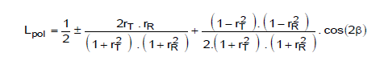

where $r_{T}$ and $r_{R}$ are the two axial rations (transmitter and receiver)

$r_{T} = 4 dB = 2.51$

$r_{R} = 3.5 dB = 2.24$

$β$ is not known so the rest is $L_{POL}=1.49=1.75 dB$

$L_{ATM}$ is a term which takes into account the gasses in the atmosphere and the rain, but both of them are negligible at our frequency

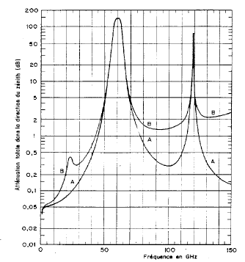

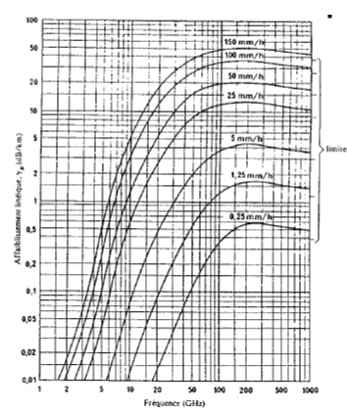

$P_{in}$ is the input power, hence 1.5W[5]=1.75dB

The link budgets for a subscriber connection to Iridium are in [6]. We look at the 2nd column because we’ll use the SBD service. We’ll compare our results to the ones